|  |
| --- |
|  |
|  |

|  |  |  |  |  |  |
| --- | --- | --- | --- | --- | --- |
| REVISION HISTORY | | | | | |
| Ver. | Description of Change | Author | Date | Approved | |
| Name | Effective Date |
| 1.0 | Initial status | [Hanna](mailto:Kiryl_Bucha@epam.com) Takushevich | 01-DEC-2012 |  |  |

Contents

1. Create package to load the Fact Table into the staging (3NF) layer 3

2. Task Results 3

# Create package to load the Fact Table into the staging (3NF) layer

The Main Task is to create independent package[s] to load your fact table to the ST layer, according to your DWH concept that was developed on Module 6 Introduction to DWH.

# Task Results

Create required objects:

* Create all required fact table objects on ST Layer (T_...).
* Grant all required privileges to ST_CL (Cleansing Layer).
* Create packages to load fact data (one package = one fact table) on ST_CL.
* Prepare document with description of your load and screenshot of data in the Fact Table.
* Test Procedure for Repeatable execution (it should produce same consistent results each time on a same source data).

Скрипты для генерации таблиц, синонимов, грантов и загрузки данных находятся в папке с отчётом.

Фактовая таблица на уровне 3нф имеет следующий вид:

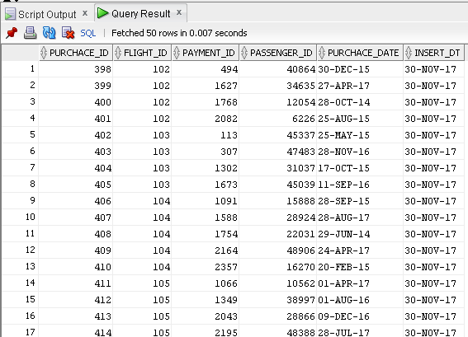

В результате схема 3нф приобрела следующий вид:

